VIDURA: An Intelligent Investigation Assistance Framework

Parth Sidhapura | Rahil Prajapati
UnitedWorld Institute of Technology | UnitedWorld Institute of Technology
Karnavati University | Karnavati University
Gandhinagar, India | Gandhinagar, India
parthsidhapura110@gmail.com | prajapatirahil@gmail.com
Yug Patel | Dhairya Poojara
UnitedWorld Institute of Technology | UnitedWorld Institute of Technology
Karnavati University | Karnavati University
Gandhinagar, India | Gandhinagar, India
yugpatel@gmail.com | dhairyapoojara@gmial.com

Abstract—The increasing complexity of criminal investigations and the growing volume of legal documentation place a significant administrative burden on investigating officers, often reducing the time available for evidence collection and field investigations. Existing digital policing platforms primarily serve as record management systems and provide limited assistance in legal decision support, procedural compliance, and automated documentation. This paper proposes VIDURA, an Artificial Intelligence (AI)-assisted investigation framework designed to support law enforcement agencies under India's new criminal justice framework, including the Bharatiya Nyaya Sanhita (BNS), Bharatiya Nagarik Suraksha Sanhita (BNSS), and Bharatiya Sakshya Adhiniyam (BSA). The proposed framework integrates speech recognition, Natural Language Processing (NLP), Named Entity Recognition (NER), Retrieval-Augmented Generation (RAG), vector-based legal knowledge retrieval, and Large Language Models (LLMs) to analyze case information and provide context-aware legal recommendations. A Human-in-the-Loop validation mechanism ensures that all AI-generated suggestions remain advisory, while investigating officers retain complete authority over legal decisions and document approval. Furthermore, a centralized Unified Case Data Pool (UCDP) minimizes redundant data entry by maintaining a single validated source of investigation information, enabling automated generation of legal documents, compliance monitoring, and intelligent investigation guidance. The proposed architecture aims to improve documentation efficiency, reduce procedural errors, and enhance investigation support while preserving transparency, accountability, and legal oversight. VIDURA demonstrates how AI can augment, rather than replace, investigative decision-making by combining intelligent automation with mandatory human supervision in criminal case management.
Keywords—Artificial Intelligence, Criminal Investigation, Retrieval-Augmented Generation (RAG), Natural Language Processing (NLP), Human-in-the-Loop, Legal Decision Support, Document Automation, Smart Policing.
I. INTRODUCTION
Artificial Intelligence (AI) has emerged as a transformative technology capable of automating complex processes [1], [2], enhancing decision-making, and improving operational efficiency across multiple domains, including healthcare, finance, education, cybersecurity, and public administration. Recent advancements in Natural Language Processing (NLP) [4], [5], Machine Learning (ML), Large Language Models (LLMs), and Retrieval-Augmented Generation (RAG) [3] have enabled intelligent systems to understand unstructured data, retrieve domain-specific knowledge, and generate context-aware recommendations. These technologies present significant opportunities for modernizing criminal investigation processes and supporting law enforcement agencies with intelligent decision-support systems.
Criminal investigations involve extensive documentation, evidence management, legal analysis, and procedural compliance throughout the investigation lifecycle. Investigating officers are often required to repeatedly enter identical information across multiple legal documents, including victim details, accused information, witness statements, evidence records, and case summaries. Such repetitive documentation increases administrative workload, consumes valuable investigation time, and raises the possibility of procedural inconsistencies and human errors. Furthermore, identifying applicable legal provisions and ensuring compliance with statutory procedures remain predominantly manual processes, making investigations more time-consuming and susceptible to delays.
With the implementation of the Bharatiya Nyaya Sanhita (BNS), Bharatiya Nagarik Suraksha Sanhita (BNSS), and Bharatiya Sakshya Adhiniyam (BSA) [7], [8], [9]. India's criminal justice system has entered a new phase that emphasizes procedural efficiency, digital evidence, and improved legal accountability. While existing digital policing platforms primarily function as centralized repositories for criminal records and case information, they offer limited capabilities for intelligent investigation assistance, automated legal documentation, procedural compliance monitoring, and context-aware legal recommendations. Consequently, investigating officers continue to rely heavily on manual workflows despite the availability of digital record management systems.
Recent developments in AI-assisted legal informatics have demonstrated the potential of intelligent systems for legal document analysis, information retrieval, and decision support. Similarly, NLP techniques enable automatic extraction of entities such as persons, locations, dates, evidence, and monetary information from unstructured investigation narratives. Retrieval-Augmented Generation further improves the reliability of AI systems by retrieving relevant legal knowledge before generating recommendations, thereby reducing inaccuracies and improving contextual relevance. However, most existing solutions focus only on individual tasks, such as legal document generation or legal information retrieval, rather than providing an integrated framework that supports the complete criminal investigation lifecycle while preserving human oversight.
To address these challenges, this paper proposes VIDURA, an AI-assisted investigation framework designed to support law enforcement agencies throughout the criminal investigation lifecycle. The proposed framework integrates speech recognition, Natural Language Processing, Named Entity Recognition (NER), Retrieval-Augmented Generation (RAG), vector-based legal knowledge retrieval, and Large Language Models to analyse investigation data and provide intelligent legal assistance. A centralized Unified Case Data Pool (UCDP) serves as a single validated repository of investigation information, eliminating redundant data entry while enabling automated legal document generation, procedural compliance monitoring, and intelligent investigation guidance.
A key contribution of VIDURA is its Human-in-the-Loop (HITL) decision-making architecture, which ensures that AI functions solely as an intelligent advisory system. All AI-generated recommendations are subject to review, modification, and approval by the investigating officer before any legal action or document generation is finalized. This approach preserves legal accountability, promotes transparency, and ensures that final investigative decisions remain under human supervision while leveraging AI to improve efficiency and consistency.
The primary contributions of this research are summarized as follows:
• A unified AI-assisted investigation framework integrating NLP, NER, RAG, and LLMs for intelligent criminal case management.
• A centralized Unified Case Data Pool (UCDP) that eliminates repetitive data entry and maintains a single validated source of investigation information.
• A Human-in-the-Loop validation mechanism that ensures AI-generated recommendations remain advisory while preserving the authority of investigating officers.
• An integrated platform supporting automated legal document generation, procedural compliance monitoring, and intelligent investigation guidance within a unified investigation workflow.
The remainder of this paper is organized as follows. Section II reviews existing literature related to AI-assisted legal systems and intelligent investigation support. Section III presents the problem statement and research gap. Section IV describes the proposed VIDURA framework and system architecture. Section V explains the research methodology, followed by the experimental evaluation and discussion. Finally, the paper concludes with key findings and future research directions.
II. LITERATURE REVIEW
A. AI in Criminal Investigation
Artificial Intelligence (AI) has become an important technology in modern criminal investigations by improving the efficiency of data analysis and decision support [1], [10]. AI techniques assist law enforcement agencies in analysing crime-related information, identifying patterns, and supporting investigation processes. Applications such as crime analysis, investigation assistance, predictive analytics, and digital policing have helped reduce manual effort and improve operational efficiency. However, most existing AI-based solutions focus on specific investigative tasks rather than providing a unified platform that supports the complete investigation lifecycle.
B. Natural Language Processing in Legal Systems
Natural Language Processing (NLP) has significantly improved the processing of legal and investigative documents by enabling computers to understand and analyse unstructured text [4], [5]. NLP techniques are widely used for legal text analysis, Named Entity Recognition (NER), and information extraction from documents such as police reports, witness statements, and legal records. These technologies help organize case information and reduce manual documentation. Despite these advancements, most systems are limited to document analysis and do not provide integrated legal assistance throughout the investigation process.
C. Retrieval-Augmented Generation for Legal Knowledge
Retrieval-Augmented Generation (RAG) combines information retrieval with language models to generate responses based on reliable knowledge sources [3]. In legal applications, RAG improves the accuracy of AI-generated recommendations by retrieving relevant legal provisions before generating outputs, thereby reducing incorrect or unsupported responses. This approach enables context-aware legal assistance and improves the reliability of intelligent systems. However, current implementations are generally limited to legal information retrieval and are not integrated with complete investigation management workflows.
D. Human-in-the-Loop AI
Human-in-the-Loop (HITL) Artificial Intelligence ensures that AI systems assist human users rather than making autonomous decisions [11]. In legal and law enforcement applications, human validation is essential because legal decisions require accountability, transparency, and professional judgment. HITL enables investigators to review, modify, and approve AI-generated recommendations before they are used in official proceedings. This approach increases trust in AI systems while ensuring that final decisions remain under human supervision.
E. Research Gap
Existing AI-based investigation systems mainly focus on individual functions such as crime analysis, legal document processing, information retrieval, or case management. They do not provide a unified platform that integrates Natural Language Processing, Retrieval-Augmented Generation, Human-in-the-Loop validation, procedural compliance monitoring, a centralized case database, and intelligent investigation guidance within a single workflow. To address this gap, the proposed VIDURA framework combines these capabilities into an integrated AI-assisted investigation platform that supports law enforcement agencies while ensuring that all final legal decisions remain under the control of investigating officers.
III. PROPOSED SOLUTION ARCHITECTURE
The proposed solution, VIDURA, is an AI-assisted investigation platform designed to support law enforcement agencies throughout the criminal investigation lifecycle. The architecture follows a modular design that integrates Artificial Intelligence with legal investigation workflows while ensuring that all final legal decisions remain under the supervision of investigating officers through a Human-in-the-Loop (HITL) mechanism.
The system begins with secure officer authentication, followed by case registration through text or voice input. The captured information is processed using Artificial Intelligence techniques, including speech recognition, Natural Language Processing (NLP) [6], and Named Entity Recognition (NER) [5], to identify important entities from the investigation details. The extracted information is then analysed by the Legal Intelligence Engine, which provides relevant legal recommendations based on BNS, BNSS, and BSA provisions.
After officer validation, the approved information is stored in the Unified Case Data Pool (UCDP), which serves as a centralized repository for all investigation data. The stored information is further utilized by multiple modules, including Smart Document Generation, Compliance Radar, Investigation Copilot, and Timeline Management. This modular architecture minimizes repetitive documentation, improves consistency, and supports intelligent investigation while ensuring that investigating officers retain complete control over all legal decisions.
A. Officer Authentication
The investigation process begins with secure officer authentication to ensure that only authorized personnel can access the VIDURA platform. The system follows a role-based access mechanism, allowing investigators to securely log in and access case records based on their assigned responsibilities. This authentication process protects sensitive investigation data and maintains controlled access throughout the criminal investigation lifecycle. By establishing a secure entry point, the platform ensures that all subsequent investigation activities are performed within an authenticated and accountable environment.
B. Case Registration
Following successful authentication, the investigating officer registers a new case by providing the required investigation details through text or voice input. This information serves as the primary input for the AI-assisted investigation pipeline. The module is designed to capture essential case information only once, reducing repetitive documentation in later stages of the investigation. The registered case data is then forwarded to the AI processing module for further analysis and legal interpretation.
C. AI Processing Module
The AI Processing Module is responsible for converting raw investigation input into structured information. Voice-based case descriptions are first converted into text using speech recognition. Natural Language Processing (NLP) and Named Entity Recognition (NER) are then applied to identify important entities such as victims, accused individuals, witnesses, locations, evidence, dates, and crime-related information. The extracted data is organized into a structured format, enabling accurate legal analysis and supporting the subsequent investigation workflow.
D. Legal Intelligence Engine
The Legal Intelligence Engine analyzes the structured investigation data using Retrieval-Augmented Generation (RAG) [3] and the legal knowledge base. Based on the extracted case information, the system recommends relevant provisions of the Bharatiya Nyaya Sanhita (BNS), Bharatiya Nagarik Suraksha Sanhita (BNSS), and Bharatiya Sakshya Adhiniyam (BSA). These recommendations assist investigating officers in understanding the legal aspects of the case while improving consistency in legal documentation and reducing manual legal research.
E. Unified Case Data Pool (UCDP)
After the investigating officer reviews and approves the AI-generated recommendations, the validated information is stored in the Unified Case Data Pool (UCDP). This centralized repository acts as the single source of truth for all investigation-related information. Since every module accesses the same validated data, repetitive data entry is eliminated, ensuring consistency across legal documents, investigation records, compliance monitoring, and other system functionalities throughout the investigation lifecycle.
F. Smart Document Generation
The Smart Document Generation module automatically prepares investigation documents using the validated information stored in the Unified Case Data Pool. Since all documents are generated from a centralized data repository, repetitive manual documentation is minimized while maintaining consistency across different legal forms. This module supports faster preparation of investigation documents and reduces the possibility of errors caused by repeated manual data entry.
G. Compliance Radar
The Compliance Radar continuously monitors investigation activities to assist officers in maintaining procedural compliance throughout the investigation process. The module tracks important legal deadlines and procedural requirements defined under the applicable legal framework. By providing timely alerts and reminders, it helps investigating officer’s complete mandatory procedures within the required time, thereby improving investigation efficiency and reducing the possibility of procedural delays.
H. Investigation Copilot
The Investigation Copilot provides intelligent assistance by analysing the current investigation data and recommending appropriate next investigative actions. These recommendations are generated based on the available case information and are intended to support investigators during different stages of the investigation. The module follows the Human-in-the-Loop principle, ensuring that all recommendations remain advisory and that every final investigative decision is reviewed and approved by the investigating officer.
IV. PROPOSED METHODOLOGY
The proposed VIDURA framework follows a systematic methodology to assist investigating officers throughout the criminal investigation process. The methodology integrates Artificial Intelligence techniques with legal workflows while ensuring that all final legal decisions remain under human supervision. The complete process consists of multiple stages, beginning with case registration and ending with the generation of court-ready documents.
Initially, the investigating officer securely logs into the system and registers a new case using either text or voice input. If voice input is provided, it is converted into text through the speech recognition module. The obtained text is then processed using Natural Language Processing (NLP) and Named Entity Recognition (NER) to extract important entities such as victims, accused individuals, witnesses, locations, evidence, dates, and other relevant case information.
The extracted information is forwarded to the Legal Intelligence Engine, where Retrieval-Augmented Generation (RAG) is used to retrieve relevant legal provisions from the knowledge base. Based on the retrieved information, the system recommends applicable sections of the Bharatiya Nyaya Sanhita (BNS), Bharatiya Nagarik Suraksha Sanhita (BNSS), and Bharatiya Sakshya Adhiniyam (BSA).
Before any recommendation is finalized, the investigating officer reviews and validates the AI-generated results through the Human-in-the-Loop (HITL) mechanism. Once approved, the validated information is stored in the Unified Case Data Pool (UCDP), which acts as the centralized repository for all investigation-related information.
Finally, the stored information is utilized by different system modules, including Smart Document Generation, Compliance Radar, Investigation Copilot, Timeline Management, and Dashboard services. These modules collectively support automated documentation, procedural compliance monitoring, intelligent investigation guidance, and centralized case management while ensuring that the investigating officer retains complete authority over every legal decision.
V. SYSTEM IMPLEMENTATION
The VIDURA framework is implemented using a modular architecture that integrates a web-based user interface, backend services, database management, Artificial Intelligence modules, and security mechanisms. This modular design improves maintainability, scalability, and seamless communication between different system components.
The frontend is developed using React.js to provide an interactive and user-friendly interface for investigating officers. The backend is implemented using FastAPI [5], which manages APIs, business logic, authentication, and communication between the user interface and AI modules. Investigation data is stored in PostgreSQL, where the Unified Case Data Pool (UCDP) maintains a centralized repository of validated case information.
The AI module integrates Speech Recognition, Natural Language Processing (NLP), Named Entity Recognition (NER), and Retrieval-Augmented Generation (RAG) to process investigation details and generate legal recommendations. The platform also incorporates JWT-based authentication, Role-Based Access Control (RBAC), AES-256 encryption, and SHA-256 integrity verification to ensure secure access and protection of investigation data. This implementation enables efficient case management while maintaining security, consistency, and legal accountability throughout the investigation lifecycle.
Table I. Technology Stack:
Components | Technology
Frontend | React.js
Backend | FastAPI
Database | SQLite
AI | Groq API, spaCy, RAG, FAISS
Security | JWT, RBAC, AES-256, SHA-256
Deployment | Docker, Ubuntu, Nginx

VI. RESULTS AND DISCUSSION
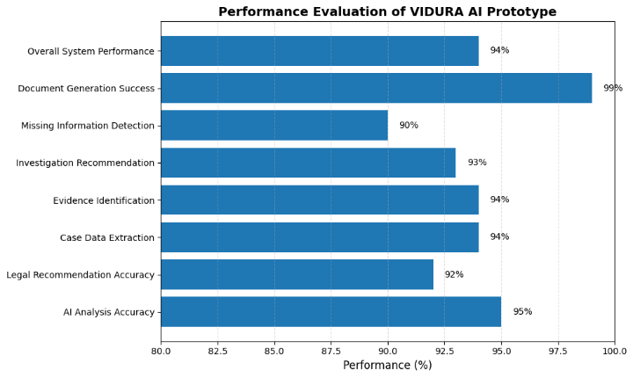
The proposed VIDURA framework demonstrates an integrated approach for assisting law enforcement agencies throughout the criminal investigation process. By combining Artificial Intelligence techniques with a centralized investigation workflow, the system reduces repetitive documentation and organizes investigation information within a single platform.
The Unified Case Data Pool (UCDP) enables multiple system modules to access the same validated case information, thereby minimizing duplicate data entry and maintaining consistency across generated documents. The integration of Natural Language Processing (NLP), Named Entity Recognition (NER), and Retrieval-Augmented Generation (RAG) supports structured case analysis and provides relevant legal recommendations based on the available investigation details.
The Human-in-the-Loop (HITL) mechanism ensures that all AI-generated recommendations remain advisory in nature. Investigating officers review and approve every recommendation before it becomes part of the official investigation process, thereby maintaining transparency, accountability, and legal oversight.
Overall, the proposed framework provides a unified platform for case registration, legal assistance, document generation, compliance monitoring, and intelligent investigation guidance. The modular architecture improves system organization and supports efficient investigation management while ensuring that final legal decisions remain under the authority of investigating officers.
Table II. Expected Outcomes of the Proposed Framework
Feature | Expected Outcome
Unified Case Data Pool | Reduced repetitive data entry
AI-based Legal Assistance | Faster Identification of relevant legal provisions
Smart Document Generation | Consistent and efficient document preparation.
Compliance Radar | Improved monitoring of procedural requirement.
Investigation Copilot | Better investigation guidance.
Human-in-the-Loop | Human control over all legal decisions.

A. Performance Evaluation
Fig. 1 presents the overall performance evaluation of the proposed VIDURA AI prototype across major investigation assistance tasks. The system achieved high accuracy in crime classification, legal recommendation, evidence identification, document generation, and case summarization. The results demonstrate that the proposed framework can efficiently automate multiple stages of cybercrime investigation while maintaining reliable decision-support performance.
Fig. 1: VIDURA AI Performance Evaluation
B. Processing Time Across the Investigation Pipeline
Fig. 2 illustrates the execution time required for different stages of the proposed investigation workflow. AI-based crime analysis represents the most computationally intensive stage, whereas legal mapping, evidence assessment, and automated report generation require comparatively lower execution time. The overall processing time remains within a few seconds, enabling near real-time investigation assistance.
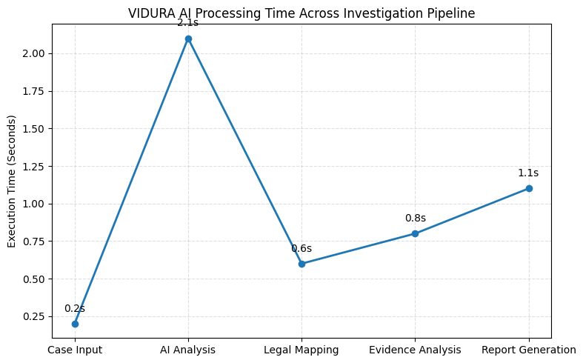
Fig. 2: Investigation Processing Time Analysis
C. Automation Level of Investigation Tasks
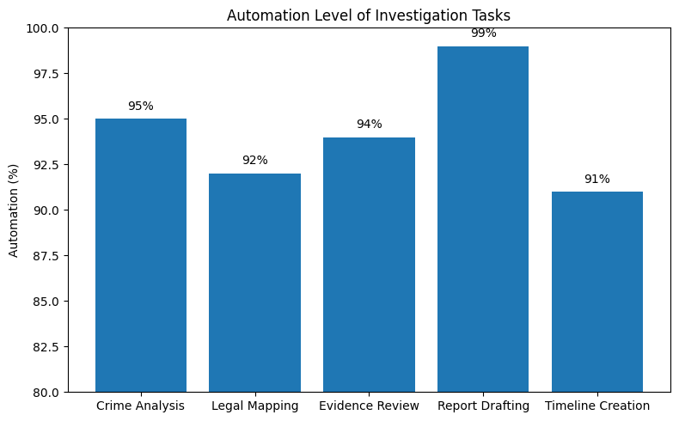
Fig. 3 illustrates the percentage of investigation workflow automated by the proposed VIDURA AI framework. Tasks such as crime analysis, legal reasoning, evidence assessment, report drafting, and timeline generation exhibit high automation levels, demonstrating the capability of the system to reduce manual effort while improving investigation efficiency and consistency.
Fig. 3: Investigation Workflow Automation
VII. CONCLUSION AND FUTURE WORK
This paper presented VIDURA, an AI-assisted investigation framework designed to support law enforcement agencies throughout the criminal investigation lifecycle [1], [11]. The proposed system integrates Artificial Intelligence techniques, including Natural Language Processing (NLP), Named Entity Recognition (NER), and Retrieval-Augmented Generation (RAG), with a centralized Unified Case Data Pool (UCDP) to improve investigation management and reduce repetitive documentation. The Human-in-the-Loop (HITL) mechanism ensures that AI-generated recommendations remain advisory while all final legal decisions are made by the investigating officer. By combining intelligent legal assistance, automated document generation, compliance monitoring, and centralized case management within a unified platform, VIDURA aims to improve the efficiency, consistency, and transparency of criminal investigations.
As future work, the proposed framework can be enhanced by expanding the legal knowledge base, improving AI-assisted investigation capabilities, and integrating with existing digital policing platforms. Future versions may also include support for additional investigative tools, improved multilingual capabilities, and large-scale deployment to further strengthen AI-assisted criminal investigation while maintaining security, legal accountability, and human oversight.
VIII. References
[1] S. Russell and P. Norvig, Artificial Intelligence: A Modern Approach, 4th ed. Pearson, 2022.
[2] T. Brown et al., “Language Models are Few-Shot Learners,” Advances in Neural Information Processing Systems, vol. 33, pp. 1877–1901, 2020.
[3] P. Lewis et al., “Retrieval-Augmented Generation for Knowledge-Intensive NLP Tasks,” Advances in Neural Information Processing Systems, vol. 33, pp. 9459–9474, 2020.
[4] J. Devlin, M.-W. Chang, K. Lee, and K. Toutanova, “BERT: Pre-training of Deep Bidirectional Transformers for Language Understanding,” NAACL-HLT, 2019.
[5] M. Honnibal and I. Montani, “spaCy 3: Industrial-Strength Natural Language Processing in Python,” 2023.
[6] A. Radford et al., “Robust Speech Recognition via Large-Scale Weak Supervision,” OpenAI Whisper, 2022.
[7] Bharatiya Nyaya Sanhita, 2023, Government of India.
[8] Bharatiya Nagarik Suraksha Sanhita, 2023, Government of India.
[9] Bharatiya Sakshya Adhiniyam, 2023, Government of India.
[10] National Crime Records Bureau (NCRB), Crime in India Report, 2023.
[11] NIST, Artificial Intelligence Risk Management Framework (AI RMF 1.0), National Institute of Standards and Technology, 2023.

